Algebra 1R Name:

Unit 1 ~ Review Sheet

Identify the independent and dependent variables for each relation.

1. The cost of a long distance telephone call increases, with the number of minutes of the call.
2. The cooking time for an unstuffed turkey is about 20 minutes per pound.

Analyze each graph and determine which of the provided scenarios it models. For each graph, label the x- and y – axis with the appropriate quantity and unit of measure

1. Cooling Tea – A freshly made cup of tea is served at a temperature of 180⁰F. The tea cools rapidly at first, and then slows down gradually as it approaches room temperature.
2. Commuter Flight – A commuter flight between two cities in Oregon takes about 40 minutes. The plane will increase its altitude for the first half of the flight until it gets to 18,000 feet, and then it will descend for the second half of the flight. The plane ascends and descents at a constant rate of 900 feet per minute.
3. 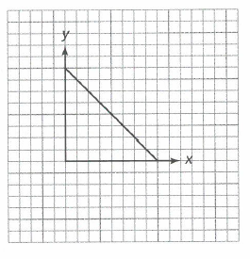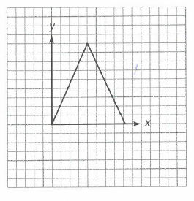 b.

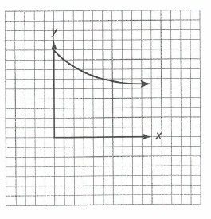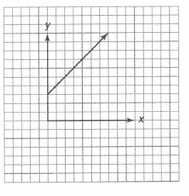

1. d.

Identify each of the following graphs as being a linear function, quadratic function, exponential function or an absolute value function.

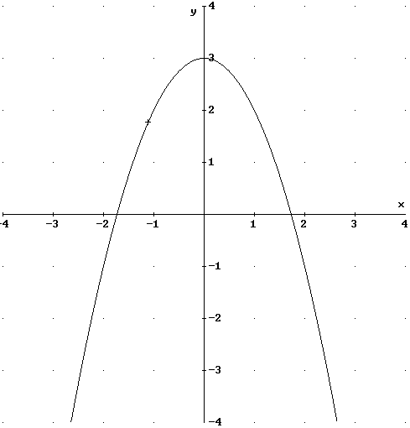

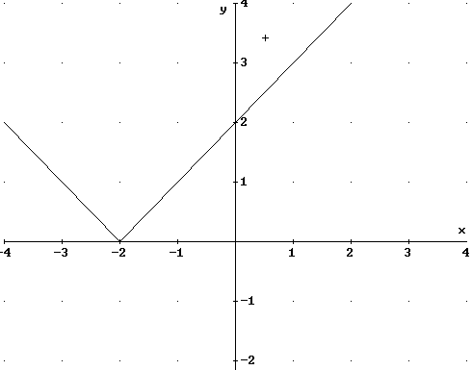5. 6.

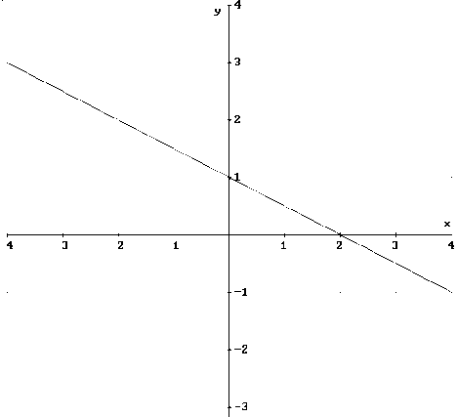

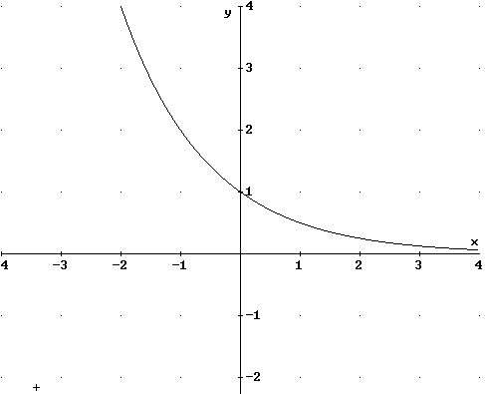7. 8.

Identify each of the following equations as being a linear function, quadratic function, exponential function or an absolute value function.

9.  10. 

11.  12.

**Properties of Numbers**

13. Commutative Property:

Addition: 5 + 7 = ______ Multiplication: 4 · 2 = _____

1. Associative Property:

Addition: (6 + 3) + 7 = _______ Multiplication: (4 · 9)5 = _____

1. Identity Property:

Addition: 2 + 0 = ______ Multiplication: 2 · 1 = _____

1. Inverse Property:

Addition: 4 + -4 = ______ Multiplication: 3 ·  = _____

1. Distributive Property:

Addition: a(b + c) = ab + ac Subtraction: a( b - c) = ab – ac

