Name: _______________________________________________
http://www.nysed.gov/next-generation-learning-standards
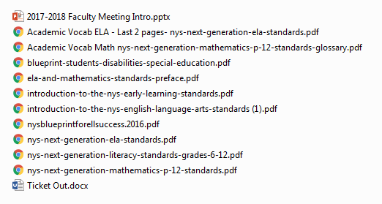
Faculty Meeting PPT- This ppt provides a 1 hour introduction to the NYSNGLS for Math and for ELA.
Academic Vocab for Math and ELA- All Read and view what are these words and how can we as a teacher, support teacher, team, grade level, or department use these words to better support our students?
Blueprint for Improved Results for Students with Disabilities- This document focuses on seven core principles and practices supported by research for all students with disabilities to improve their results in the classroom to meet the same standards. All teachers should read this to ensure everything that they are doing support these seven principals.
Blueprint for ELL Success – This document focuses on eight principals for all English Language Learners to improve their results in the classroom to meet the same standards. All teachers should read this to ensure everything that they are doing support these eight principals.
ELA and Math Standards Preface- Summary of all of the changes with the Math and ELA Learning Standards.
NYSNGELALS - New York State Next Generation English Language Arts Learning Standards. All who view this document can
NYSNGMLS- New York State Next Generation Math Learning Standards (Introduction pages 3) All should read pages 3-9 of this document. This document also lists all of the standards and how to read them.
Introduction to the NYSNGELALS- All should read this introduction to better understand the why, what, and how these standards have changed.
NYSNG Literacy Standards 6-12- Literacy in History/Social Studies, Science, and Technical Subjects. All pertaining to those subjects should read these.

Please read the documents that pertain to you that are on the L drive and answer the questions below. When you have completed this, please return this to your building principals.

- What will curriculum now look like in my class?

- What will assessments now look like in my class?

- What will instruction now look like in my class?

- What will my standards now look like in my class?

- Has any of my biases about these four categories changed? Will I have to unlearn or relearn anything?

