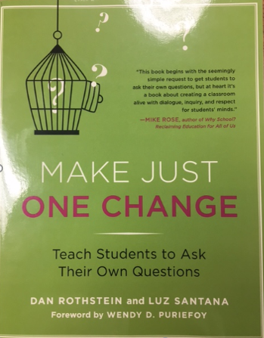

**Question Formulation Technique:**

**Summary By: Lori Krelie and Georgia Weed**

Question Focus (Teacher Created)

***It jumpstarts students questioning.***

1. It has a clear focus
2. It is not a question

Also…

1. It provokes and stimulates new lines of thinking
2. It does not reveal teacher preference or bias.

Examples of QF:

*Defeating math anxiety

*The choices we make

*The inside of a cell

*Your rights are protected by the Constitution.

Next Step

First Step

Produce Your Questions

Four Rules to do this:

1. Ask as many questions as you can.
2. Do not stop to discuss, judge or answer the questions.
3. Write down every question exactly as it is stated.
4. Change any statement into a question

Improve Your Questions

Categorize the questions as close-or open-ended:

*Closed-ended questions*: They can be answered with yes or no or with one word.

*Open –ended questions*: They require an explanation and cannot be answered with a yes or no or with one word.

<Find closed ended questions, mark them with a C. The other questions must be open –ended, mark them with an O.>

Prioritizing the Questions

Choose your three most important questions:

As a group discuss why did you choose these three as the most important?

Next Steps:

How are you going to use your questions?

**RQI**

**Technique/Protocol**

**(Student Steps)**

*The Question Formulation Technique (QFT) is a step-by step process designed to facilitate the asking of many question. But it does more than that- it takes students through a rigorous process in which they* ***think*** *more deeply about their questions,* ***refine*** *them, and* ***prioritize*** *their use.*