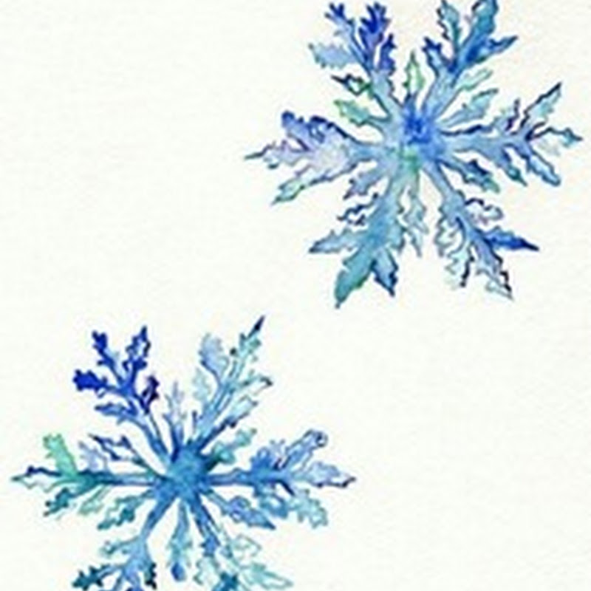 | From the first grade classroom of Mrs. Park  Weekly Class News
December kapark@svecsd.org please contact me if you have any questions or concerns
Mon | Tues | Wed | Thurs | Fri
 |  |  | 1  D day-PE sneakers | 2  A day-Music
5  B day-PE sneakers | 6  C day-Art | 7  D day-PE sneakers | 8  A day-Music | 9  B day-PE sneakers
12  C day-Art | 13  D day-PE sneakers | 14  A day-Music | 15  B day-PE sneakers | 16  C day-Art
19  D day-PE sneakers | 20  A day-Music | 21  Pre-K - 2 Concert  9:00 & 1:45  B day-PE sneakers | 22  Winter Party  C day-Art | 23  No School  Winter Break
26  Winter Break | 27  Winter Break | 28  Winter Break | 29  Winter Break | 30  Winter break

ELA/Skills: Spelling, now it’s time to put what we have been working on into action. Spelling words will consist of these skills; double ee makes the long e sound, the silent makes the first vowel say it’s while the e stays silent. We will begin identifying verbs or action words, and continue with nouns: person, place, or thing as well as proper noun. Please practice sight/tricky words to help your child become a successful reader. Sight words are on the back of the newsletter Also, please try and read every night, THANK YOU for helping us become fluent readers☺
a | to | were | the | was | of | from | one | me | their | your
I | some | have | who | where | is | are | do | she | by | because
so | all | are | said | which | why | here | he | we | my
no | word | once | says | what | when | there | be | they | you
Math: Solve Word Problems with subtraction of 9 from 10; subtraction of 9, 8, & 7 from teen #’s, relate counting on to making ten & taking from ten; and compare efficiency of counting on and taking from ten.
Social Studies: building community, being respectful and responsible bucket fillers
Listening & Learning: Hopefully you have had a chance to ask questions about what they are learning in the Early World Civilization, which involves Mesopotamia, Egypt and so much more in Domain 4 of the Engage NY Listening and Learning Domains.
STEM: The next two weeks we are asking the Big Question: How can you use what you know about rolling to engineer a rollercoaster? Again, it’s all about motion!!!
Snack Time: please provide your child with a simple grab and go snack, our time is so limited.
Don’t forget: please be sure to turn in your activity page. It’s as simple as, after you read your library book jot down “we read the book Piggie Pie” This is reflected on the “completes homework on time” section of the report card

